Related topics
Beam hardening, artefacts, and algorithms
Principle
The CT principle is demonstrated with the aid of simple objects. In the case of very simple targets, only a few images need to be taken in order to achieve a good result. The more complicated the objects are, the more images are necessary in order to show all the details. In addition, special samples are used to demonstrate how artefacts are generated and what causes beam hardening.
Equipment
1 | XR 4.0 expert set | 09110-88
1 | XR 4.0 XRIS | 09057-40
1 | XR 4.0 XRstage | 09057-42
1 | Set of accessories | 09005-43
 | Additional equipment
 | PC, Windows7® or higher

This experiment is included in the upgrade sets "XRCT computed tomography".
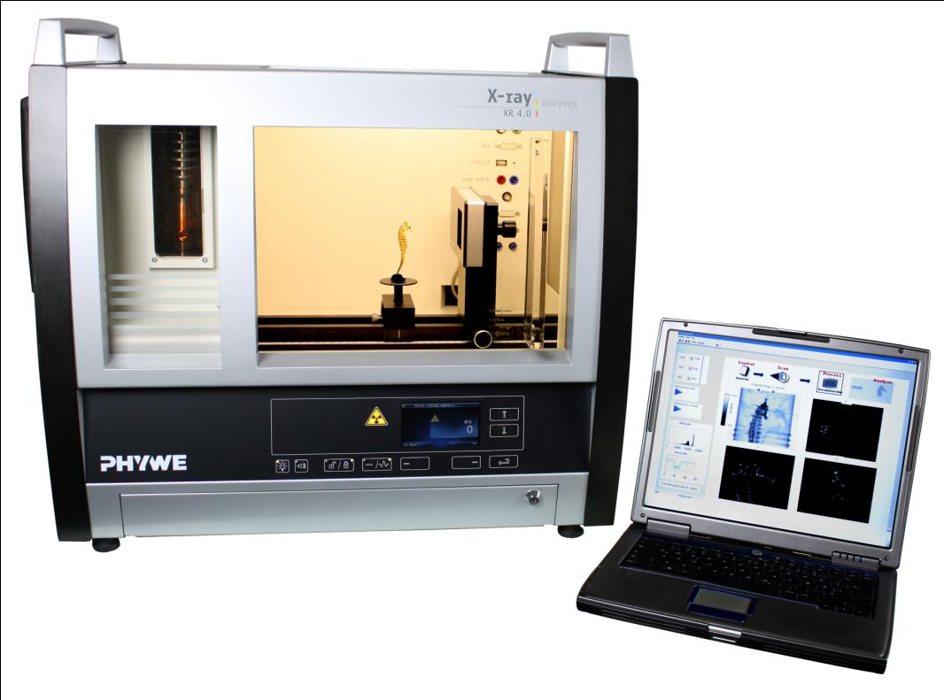
Fig. 1: P25540100
Tasks
- Record a CT scan of the simple objects. While doing so, vary the number of steps.
- Record a CT scan of the metal samples and analyse the result in view of beam hardening.
Set-up
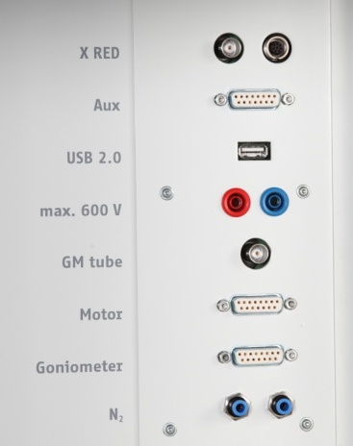
Fig. 3: Connector inside the experiment chamber
Connect the rotary stage XRstage to the corresponding connector in the experiment chamber (see the marking in Fig. 3). Connect the X-ray camera XRIS directly to the PC by way of a USB cable. The PC and X-ray unit are connected by way of the data cable and via the USB port (the corresponding connector on the X-ray unit is marked in Fig. 2). Fasten the rotary stage to the motor with the aid of the small knurled screw. Ensure that the selected object is securely connected to the stage and that it cannot change its position during the scan.
Note
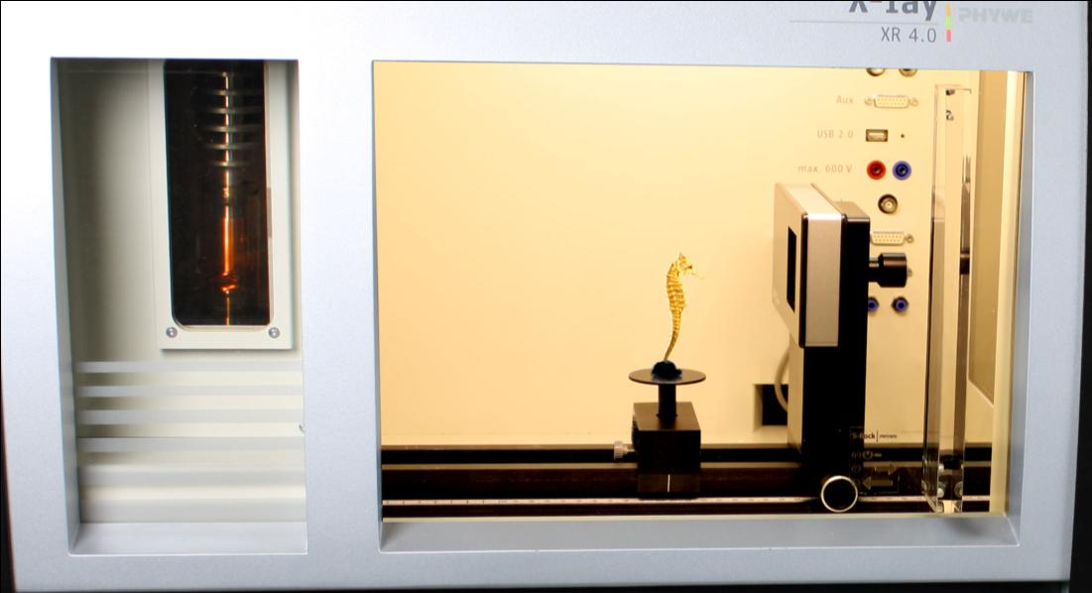
Knurled screw for fastening the stage
Rotary stage
XRIS on holder
Fig. 4: Set-up in the X-ray unit
Details concerning the operation of the X-ray unit and its CT accessories can be found in the respective operating instructions.
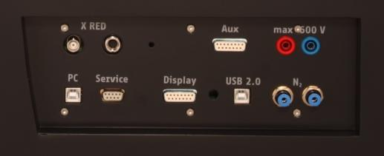
Fig. 2: Connection of the computer

Procedure
- Start the "measure CT" program. The program displays a dialog box requesting the user to calibrate the camera. Remove any objects located between the camera and the X-ray source. Lock the door and click the "Calibrate" button (1) in the software.

1st mode: "Live image and settings", Fig. 5
- Adjust the distance between the source and the object (2) or between the source and the camera (3). Select 200 projections per 360° (4).
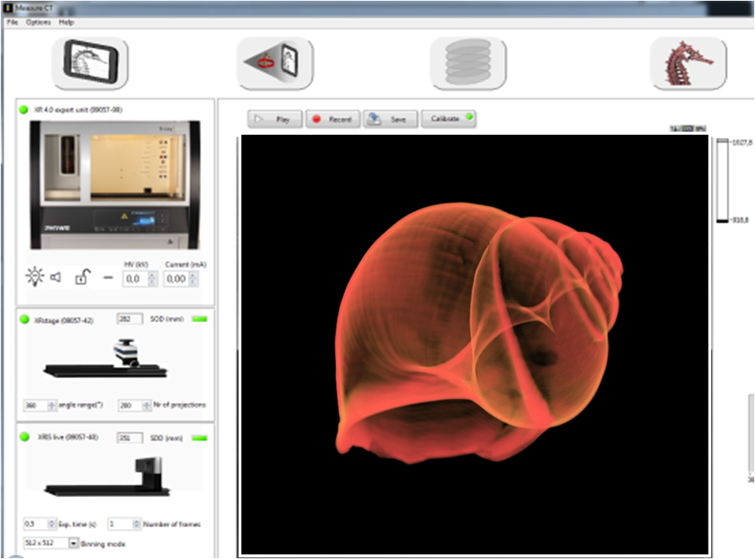
6
5
4
3
1
2
Fig. 5: Screenshot in the mode "Live image and settings"
- Now, place an object in front of the active area of the camera and click "Play" (5). In order to interrupt the live mode, click "Play" again.
Check the position of your sample and click the next status "CT scan" (6) when you want to start a scanning process.

2nd mode: "CT scan", Fig. 6
- Click "Scan" (7) and create a new folder. Open the folder and click "Current folder". The scan will start automatically. The remaining time will be displayed next to the status bar (8).
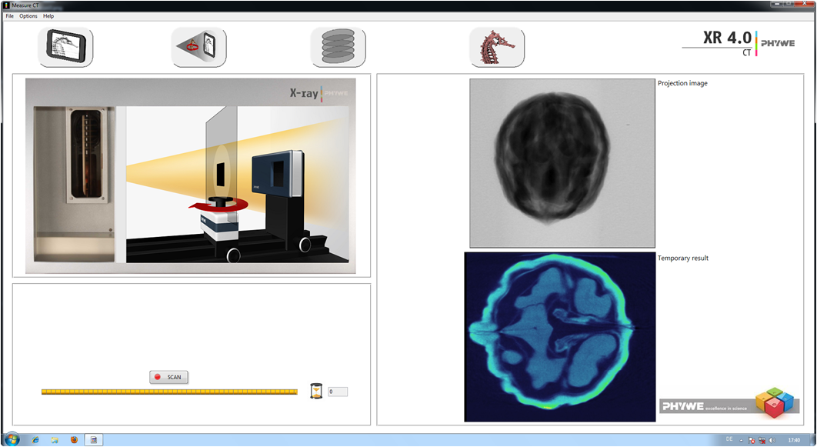
8
7
Fig. 6: Screenshot in the "CT scan" mode
3rd mode "Reconstruction", Fig. 7
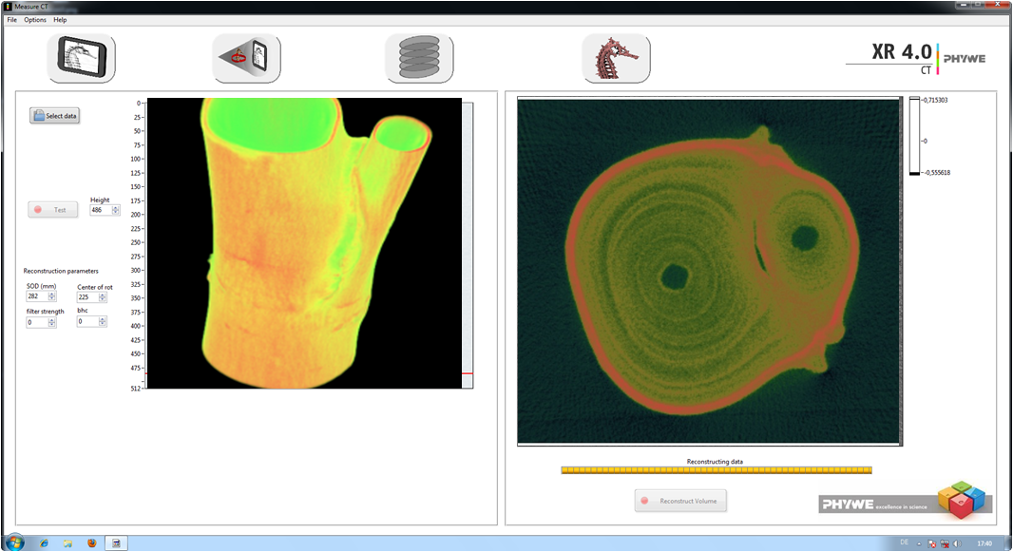
12
11
103
9
Fig. 7: Screenshot in the mode "Reconstruction"
Click "Select data" (9) in order to open the correct folder. Click "Current folder". Change the COR value (centre of rotation) (10) until the sectional image (11) is satisfactory.
Then, click "Reconstruct volume" (12). It will now take approximately 3 minutes for the reconstructions to be complete.

4th mode "3D view", Fig. 8
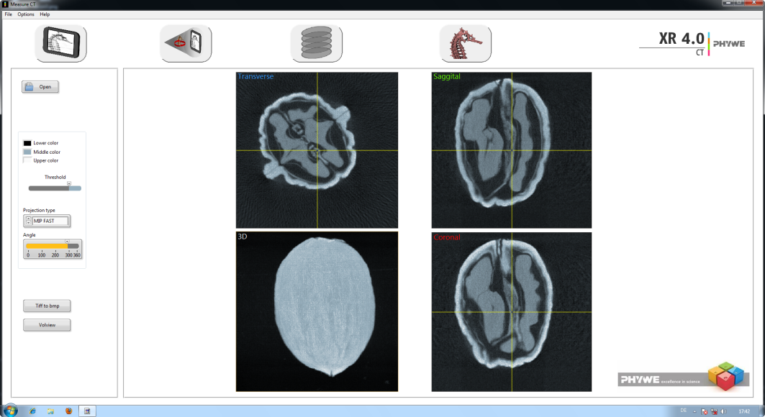
173
163
153
143
133
Fig. 8: Screenshot in the mode "3D view"
Open your data with the aid of "Open" (13). When you click the bar under "Angle", the 3D view will be displayed. Scroll through the layers by moving the fine lines with the mouse while keeping the left mouse button pressed (15).
Export: Click "Tiff to bmp" (16) and - after the bmp files have been created - click "Volview" (17). The Volview software will open automatically.
Theory
Computed tomography (CT) is a procedure for creating superposition-free sectional images of a body or object. It enables doctors to see the inside of their patients. This makes it indispensable for medical diagnostics. However, computed tomography goes beyond medical applications. As a non-destructive method, it is also used in numerous ways in material testing applications.
Nowadays, volume images of the test objects can be created with modern computer programs. Apart from computed tomography, other important imaging techniques are magnetic resonance imaging (MRI) and ultrasound tomography (UST). These techniques differ from each other more or less strongly in terms of the actual method as well as in terms of their application in various medical fields. CT, for example, is often used to visualise the "hard" elements of the body, e.g. bones, whereas magnetic resonance imaging is more suitable for the visualisation of soft tissues.

X-ray imaging is the projection of a three-dimensional object on a two-dimensional plane:
- Inner structures are superimposed.
- The exact position of different organs is difficult to determine.
During a CT scan, sectional images are created based on two-dimensional images and with the aid of special algorithms.
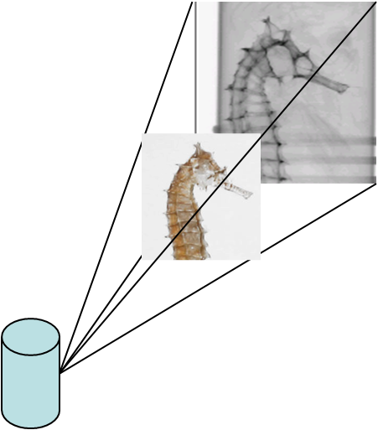
Fig. 9: Principle of an X-ray scan

Fundamental principles of the image acquisition during computed tomography
The technique is based on the so-called "filtered back projection" (the method is based on Johann Radon).

The computer divides the object into a square matrix. This matrix corresponds to the pixels of the image.
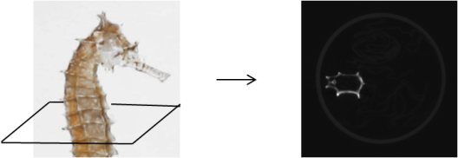
Fig. 10: Principle of a CT scan

The measured intensity is converted into levels of grey and then entered into this square matrix along the beam path. It is not known where exactly the attenuation occurred.
Let us take only one section of the 3D object:
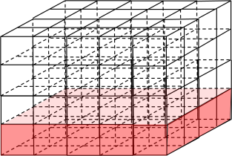

As a result, we obtain one square:

In the case of a very simple object, images taken from 2 sides are already sufficient.

Example

The superposition now indicates the location of the object:

